1. Build a manual ci-cd pipeline for a java application and also write a simple test.sh for testing , after that convert the same in automated ci-cd pipeline using jenkins but you have to also use maven for java application.

* Understanding CI/CD Concepts, Jenkins and Project Setup
* Manually deploying Java-Maven application
* Jenkins Deployment - freestyle
* Create Your First Jenkins Pipeline
* Building Jenkins Pipeline to deploy applications
* Deploying application on the VM
* Moving Jenkins pipeline to Jenkinsfile in SCM
* Adding triggers to trigger a build

2.Create an EC2 intance for a Reactjs application and deploy the application and provide the public ip for it, also enable the cloud monitoring on these instances.

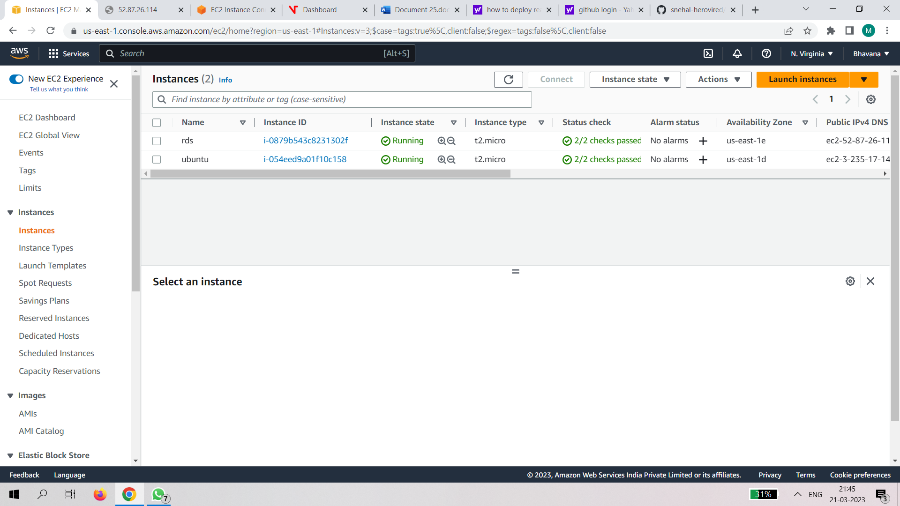

Step2: connect

⌨ Source Code

#Update ubuntu instance

sudo apt-get update

#Upgrade ubuntu system

sudo apt-get upgrade

#install ngnix

sudo apt-get install nginx -y

#nginx version

nginx -v

#restart nginx

sudo systemctl restart nginx

#install nodejs ubuntu

sudo apt-get install curl

curl -sL https://deb.nodesource.com/setup_14.x | sudo -E bash -

sudo apt-get install -y nodejs

#reate the react project. (create-react-app)

npx create-react-app react-tutorial

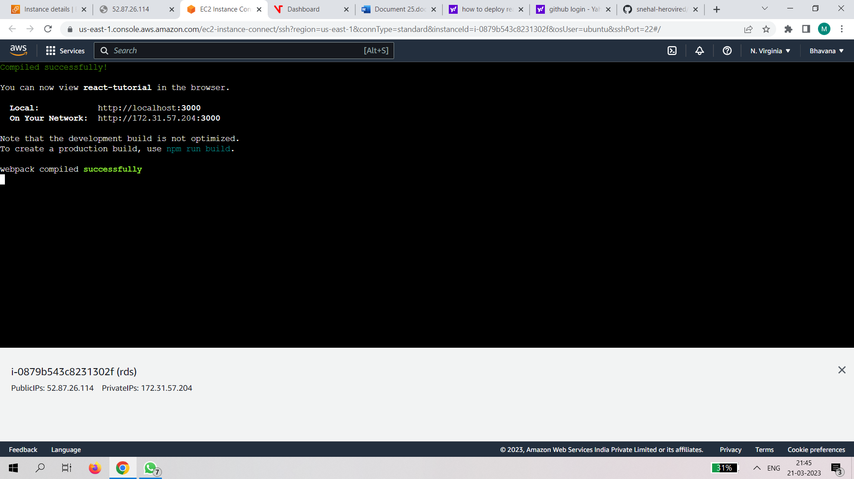

Step 3:

Click on monitoring

Click onManage cloud monitoring

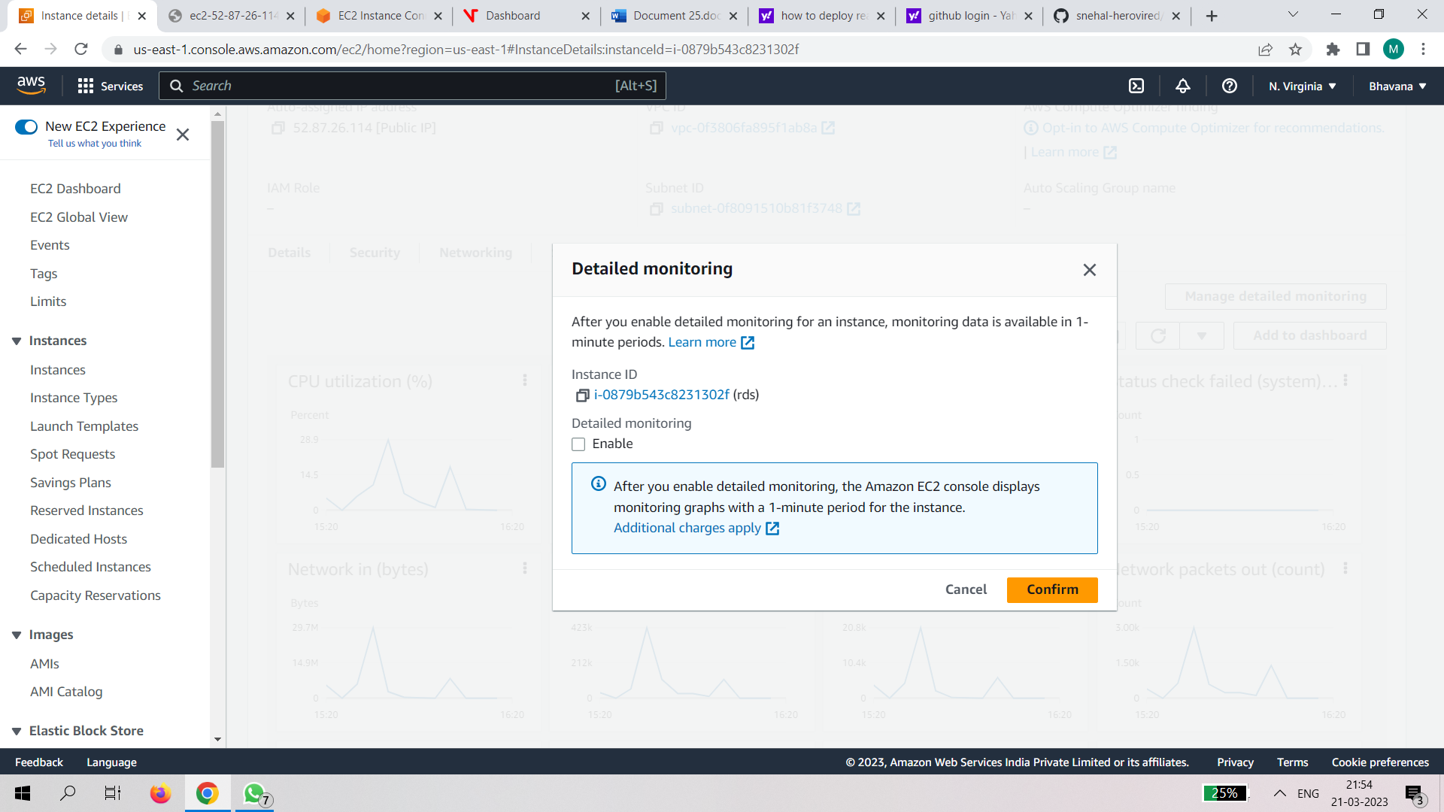

Step4:create dashboard

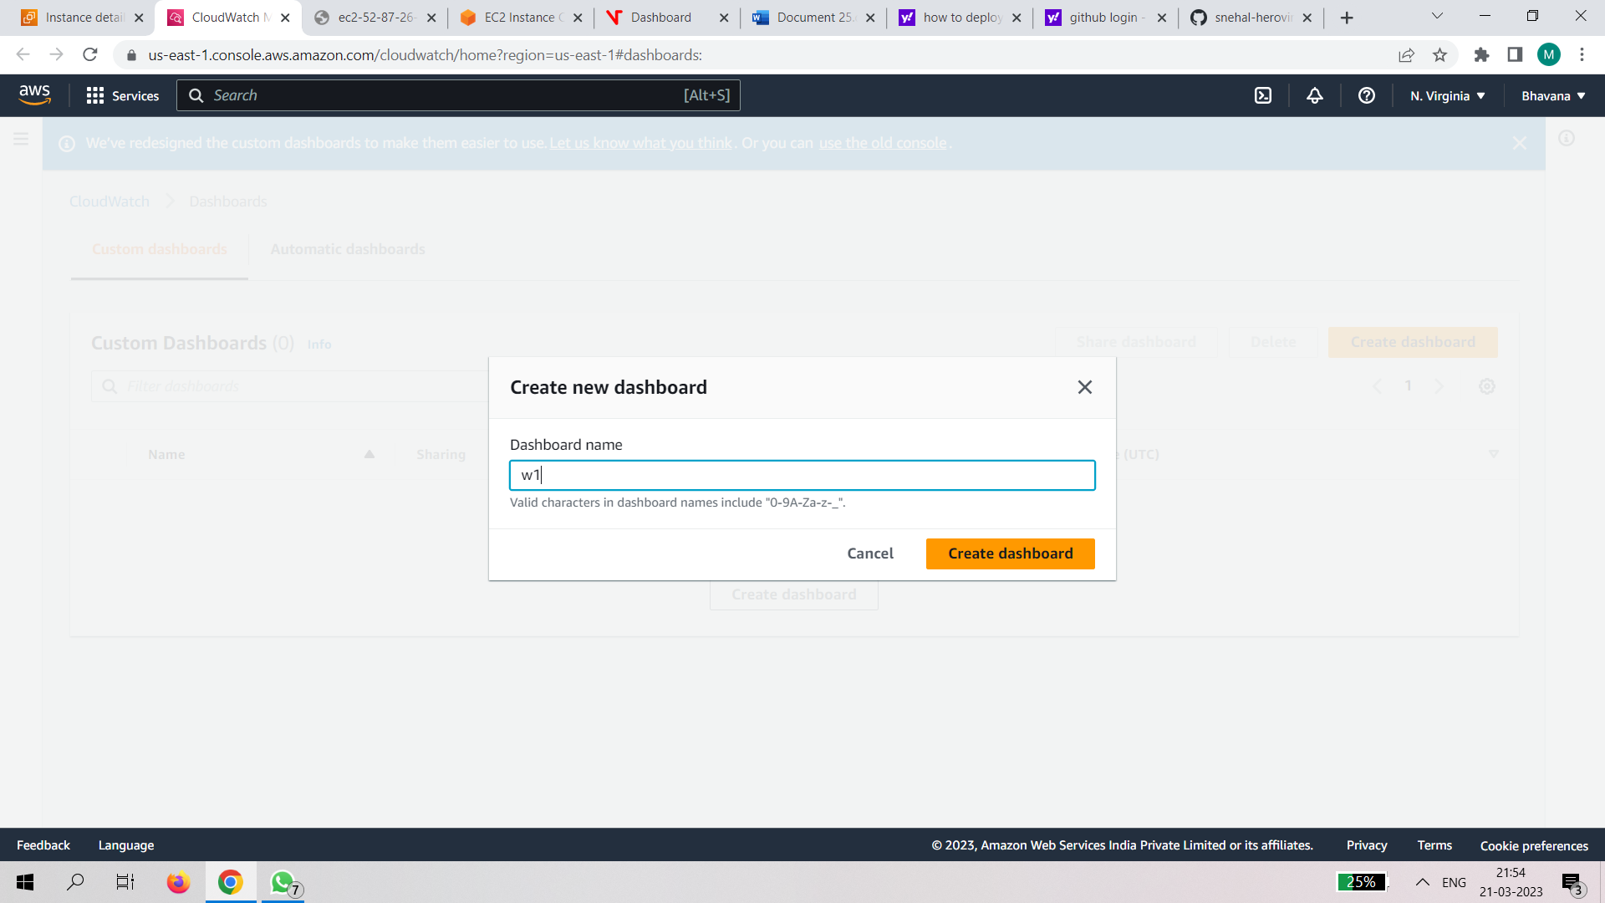

Step 5:click on the monitoring

b 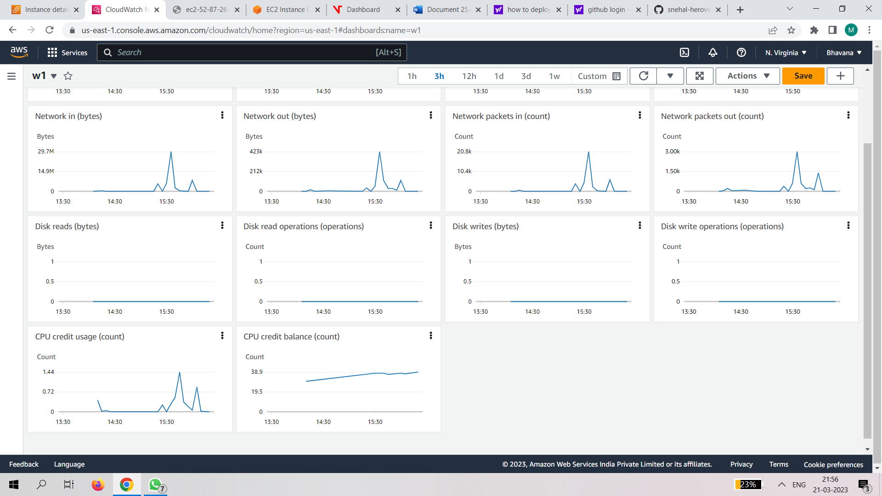

Step 6:copy the public ip and paste in the new tab

s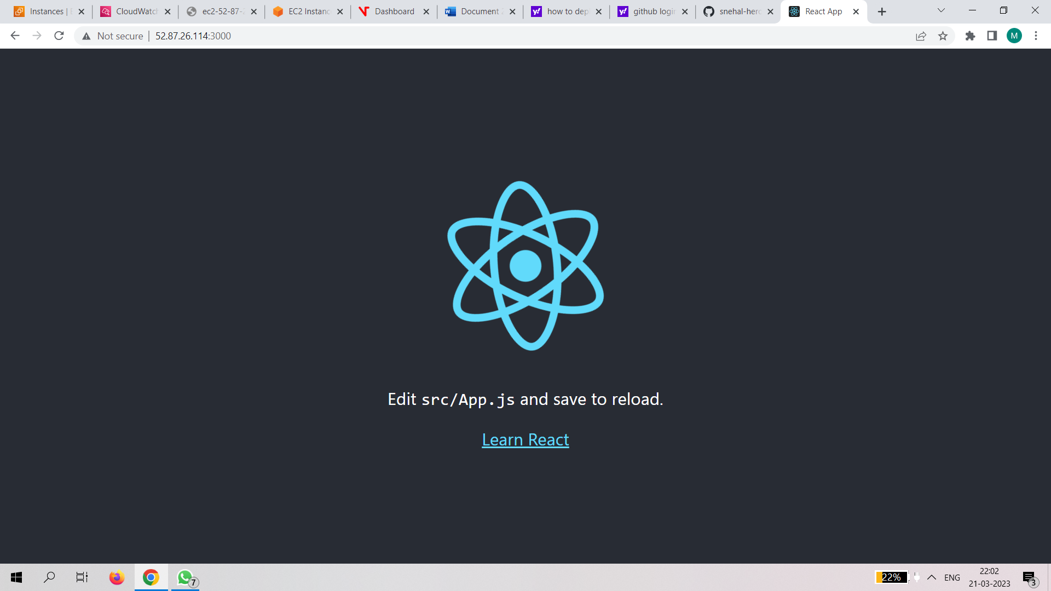

3.Create an rds connection with ec2 instance and use it to create an sql database and a sample table.

Step1:create an instance

Click on edit security rules

Add security rules

Click on lanuch instance

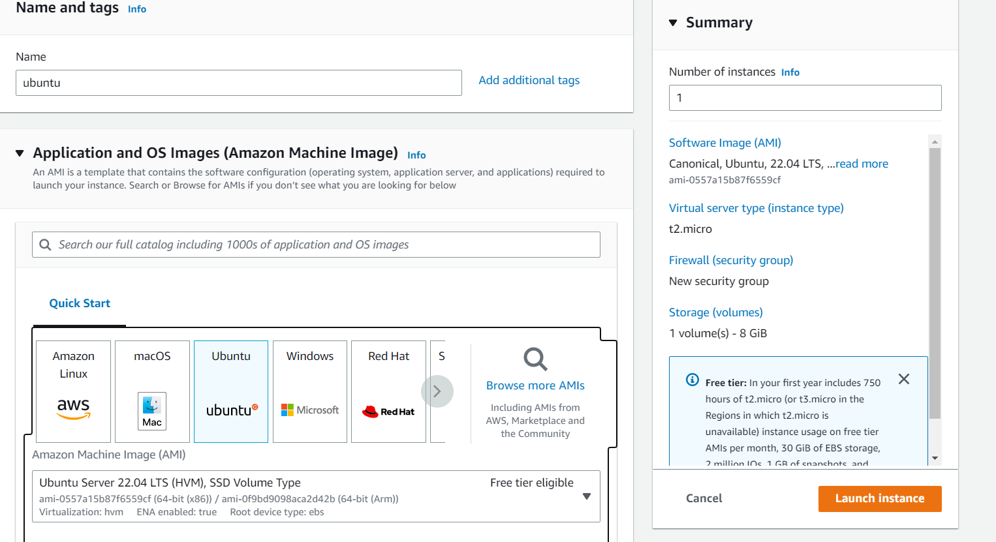

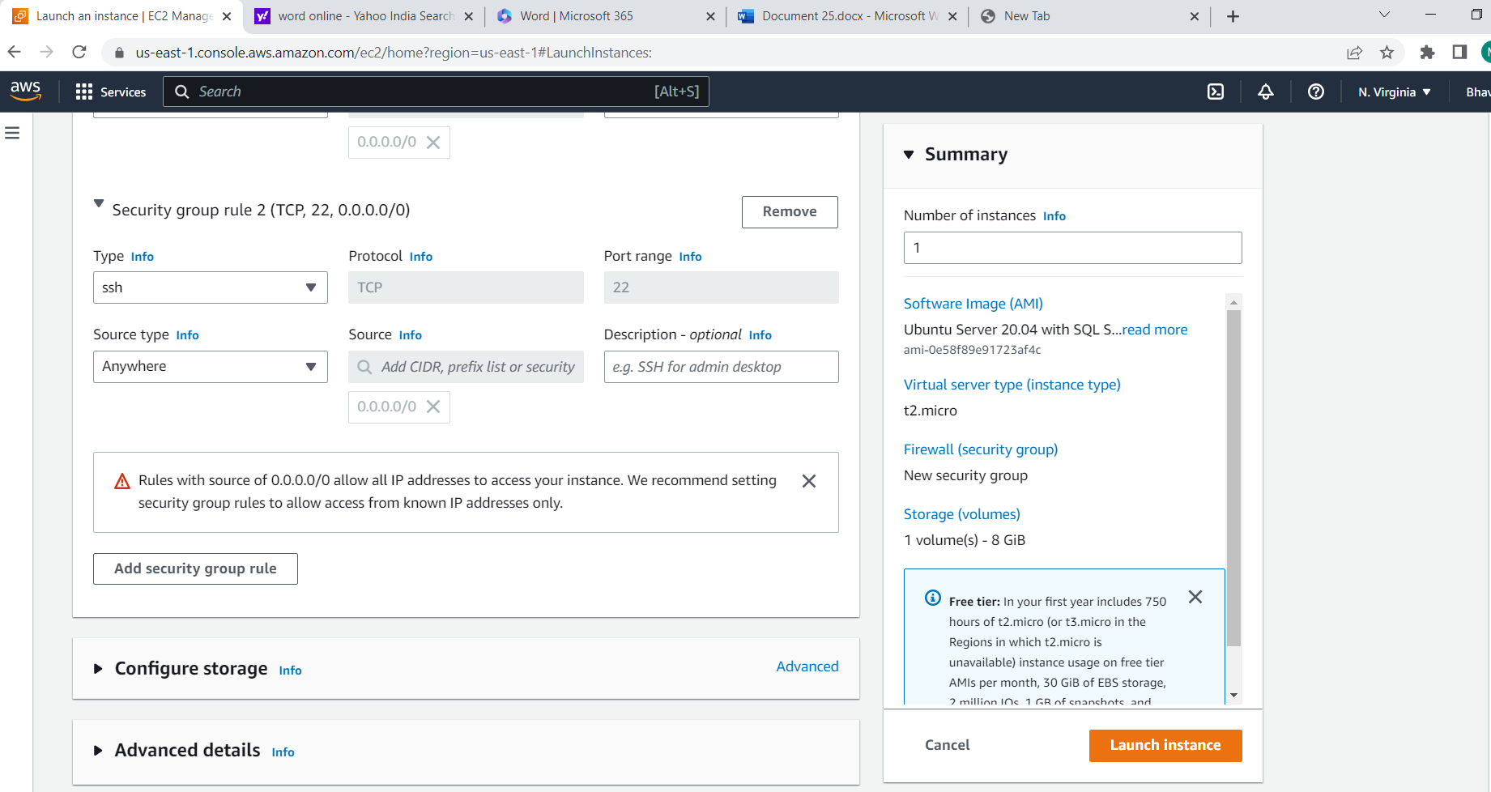

Step2:

Create a database

Search for the rds in services

Click on create database

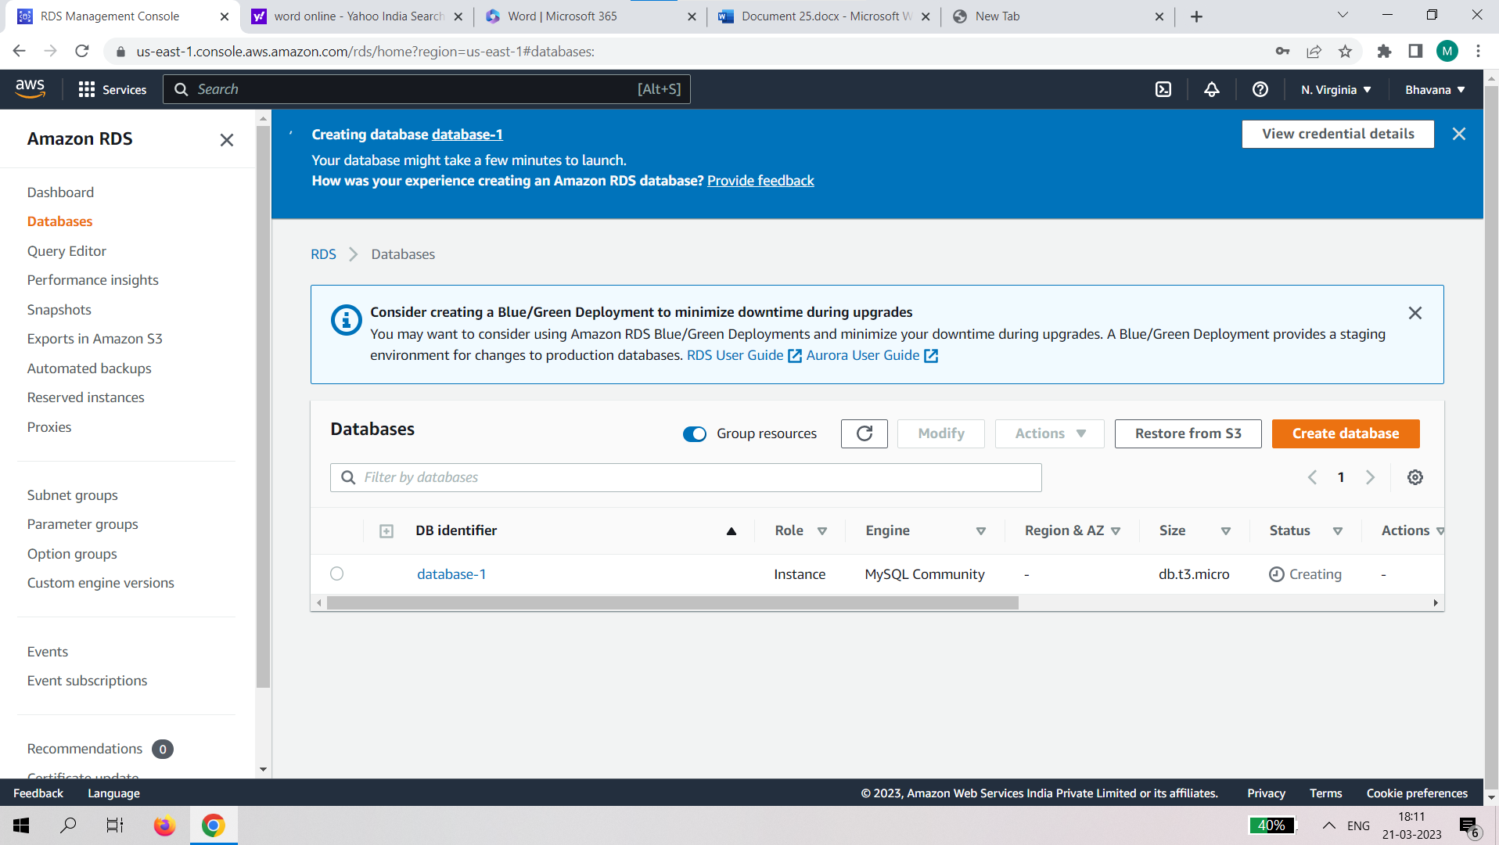

Step3 : click on setup ec2 connection

Connect the database with the launched instance

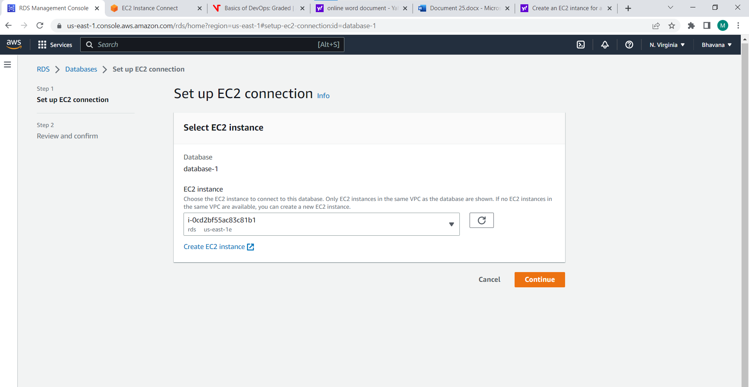

Step 4:select the instance and connect

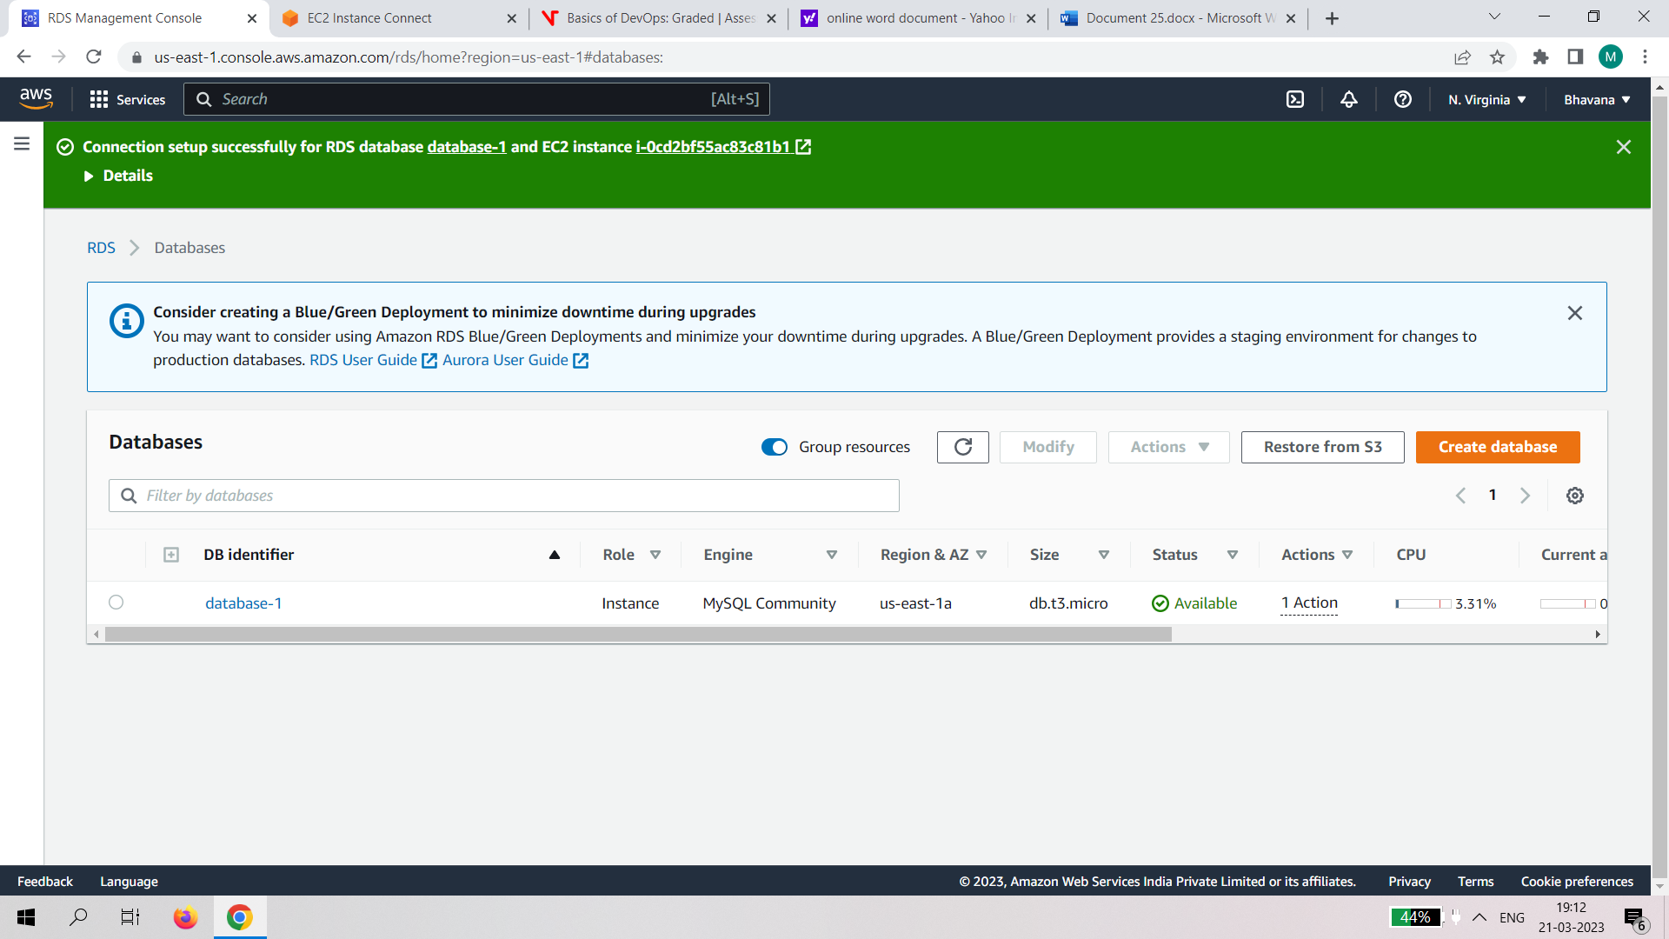

Step 5:

Click on the instance and connect

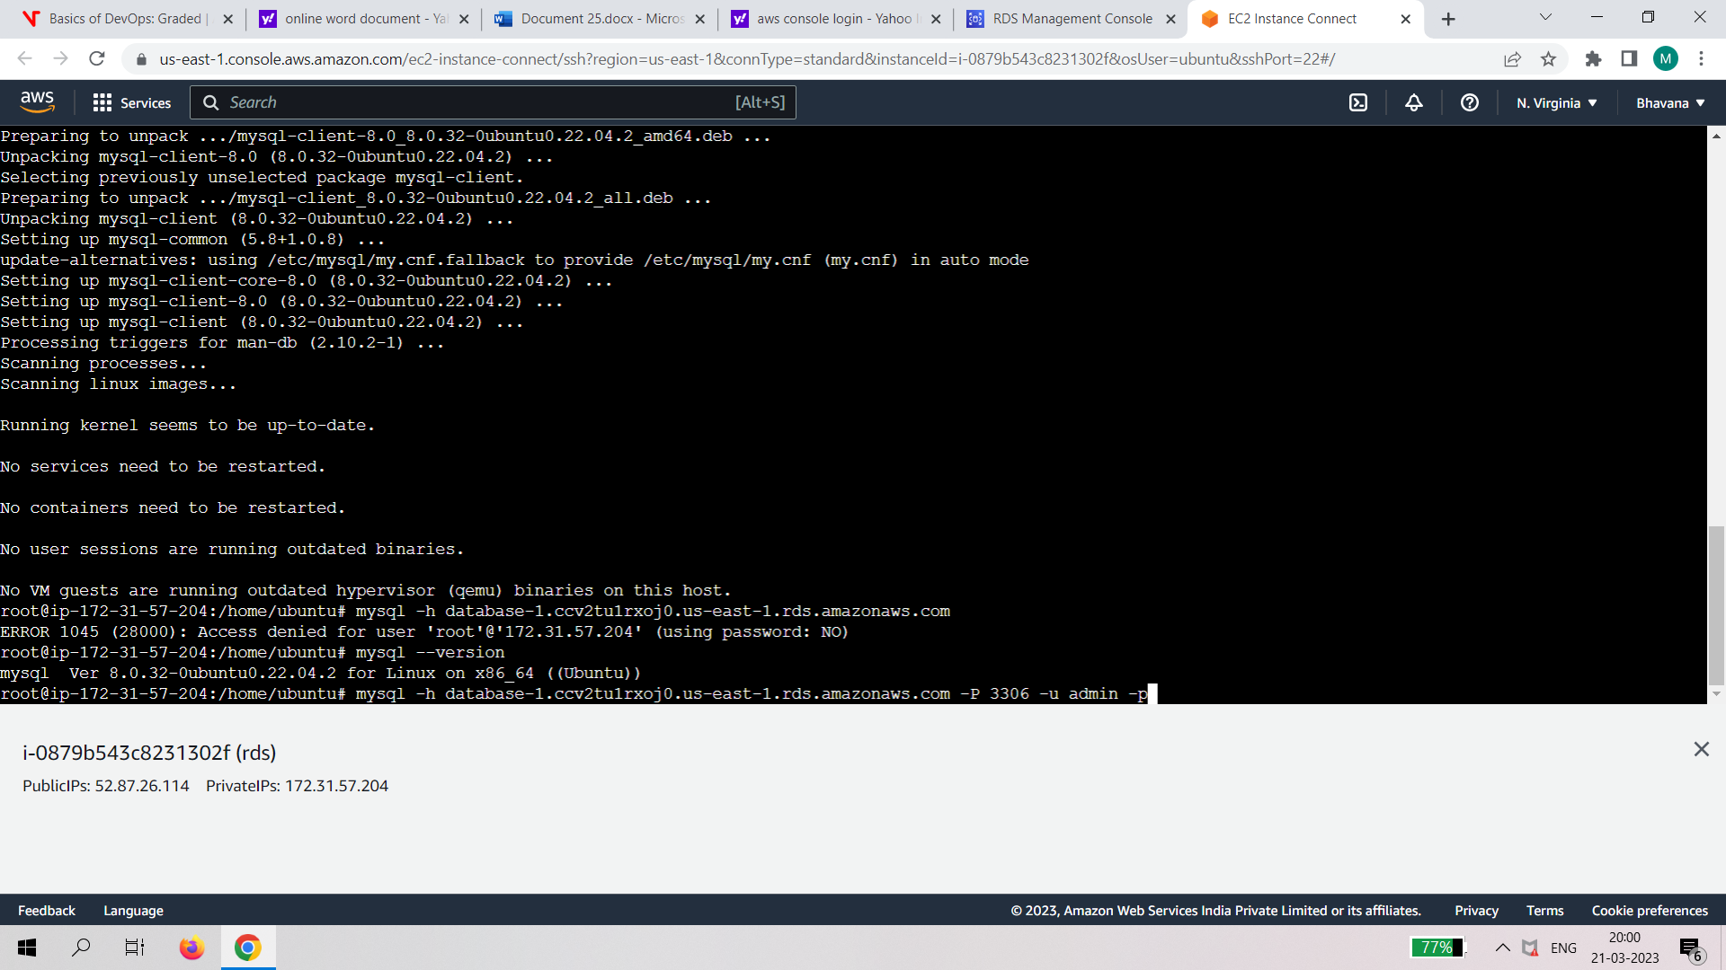

Step6:

1.sudo su

2.apt-get install mysql-client

3.y/n-->y

4.mysql -h <RDSendpoint> -P 3306 -u admin -p

5.password:

6.CREATE DATABASE <database_name>;

7.USE <database_name>;

8.CREATE TABLE <table_name> (id INT NOT NULL AUTO_INCREMENT, name VARCHAR(50) NOT NULL, PRIMARY KEY (ID));

9.INTO <table_name> (name) VALUES ('your name')

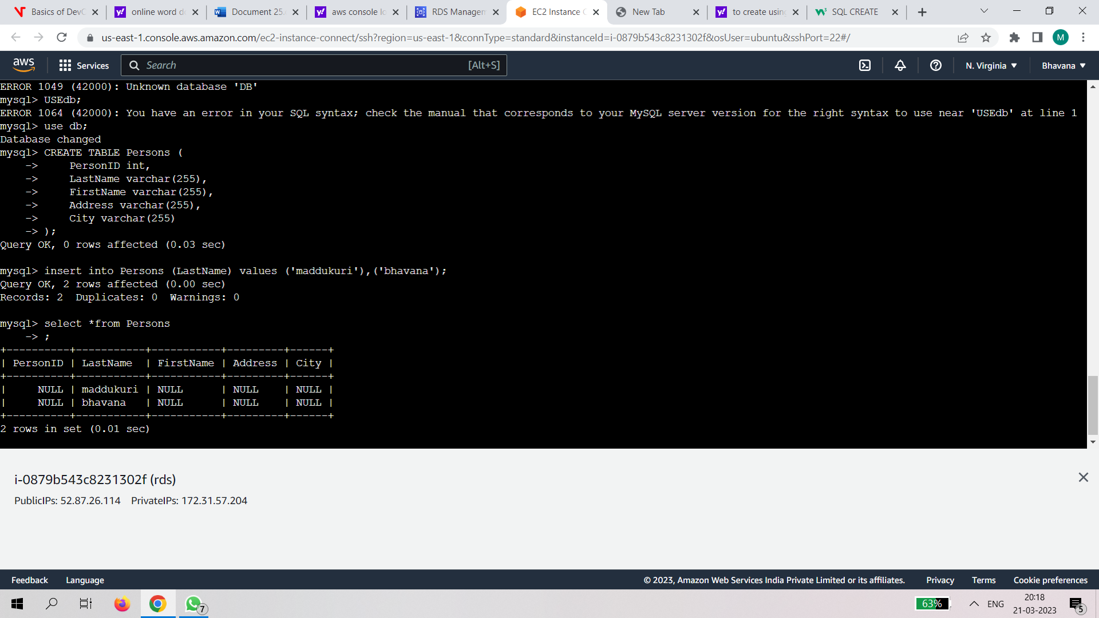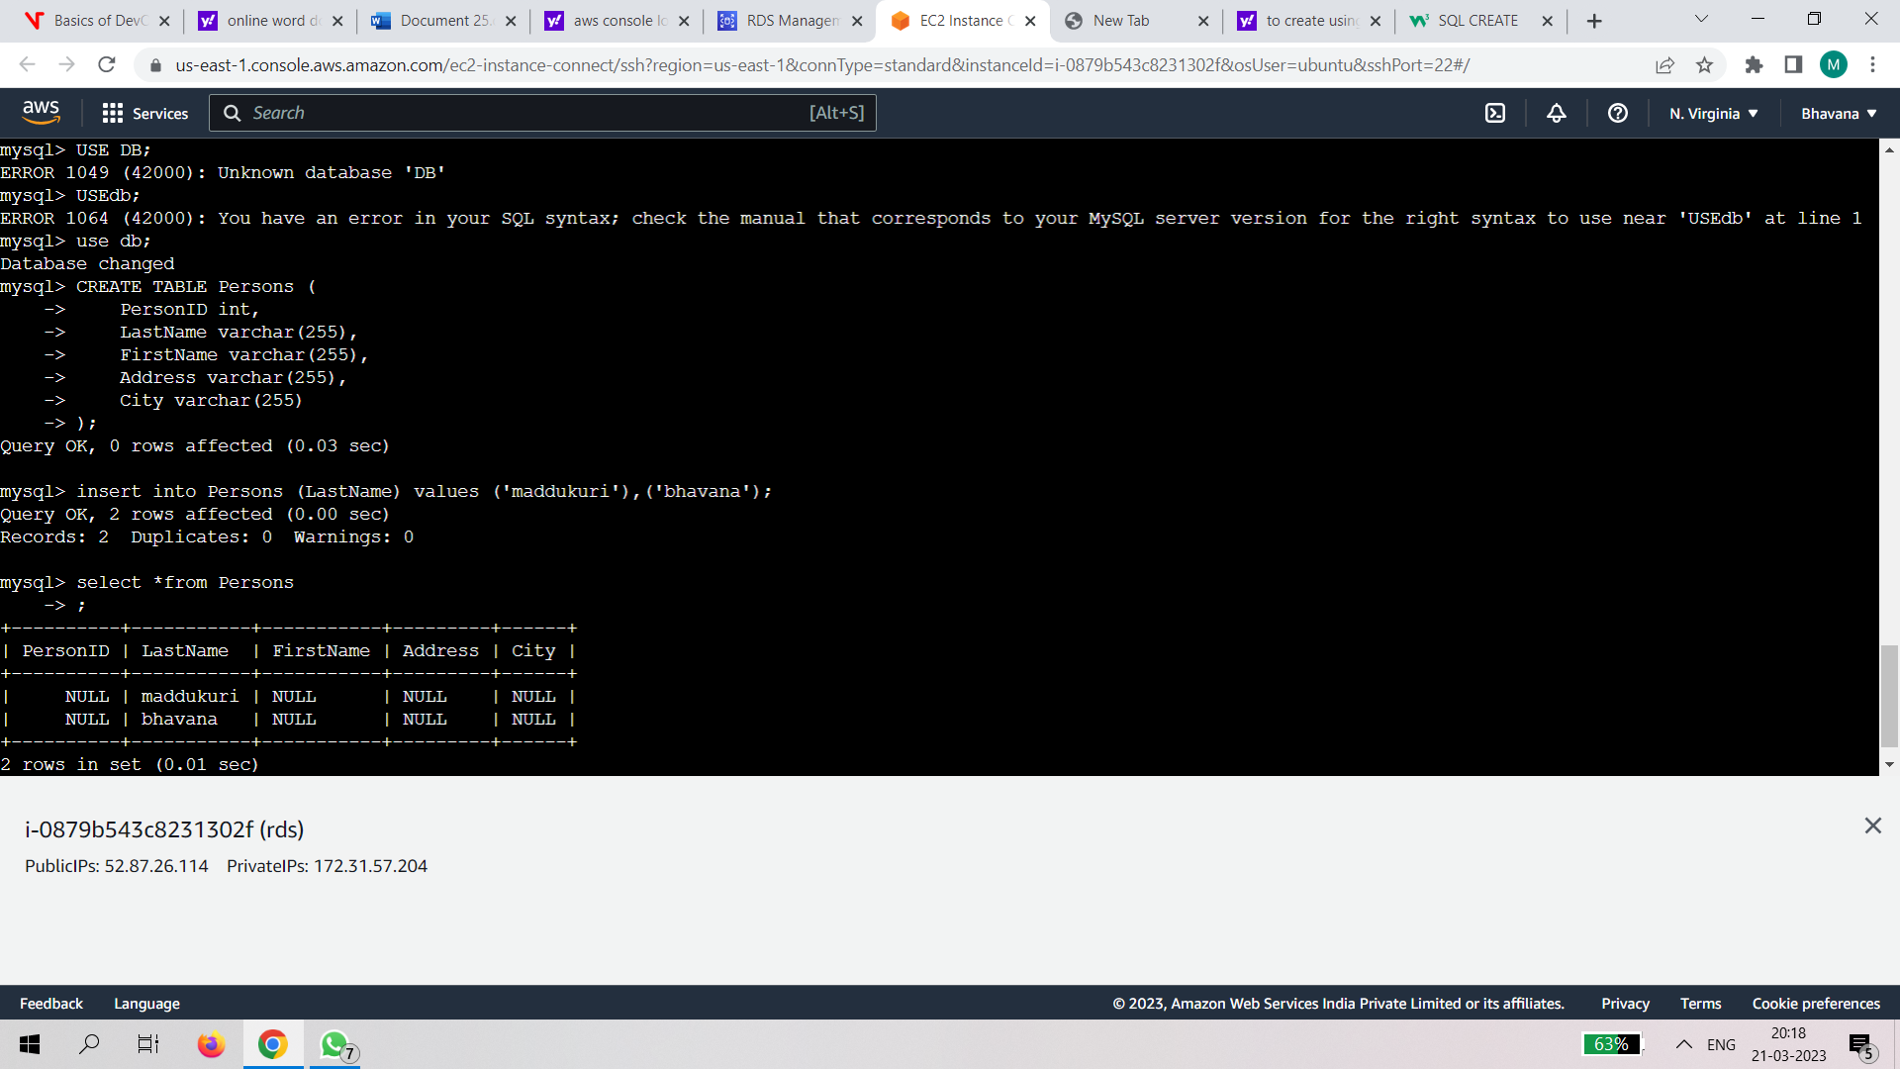

4.Create an S3 bucket and deploy the reactjs static application on it and provide with the public url for use.

Step1 :create s3 bucket

->give access enable

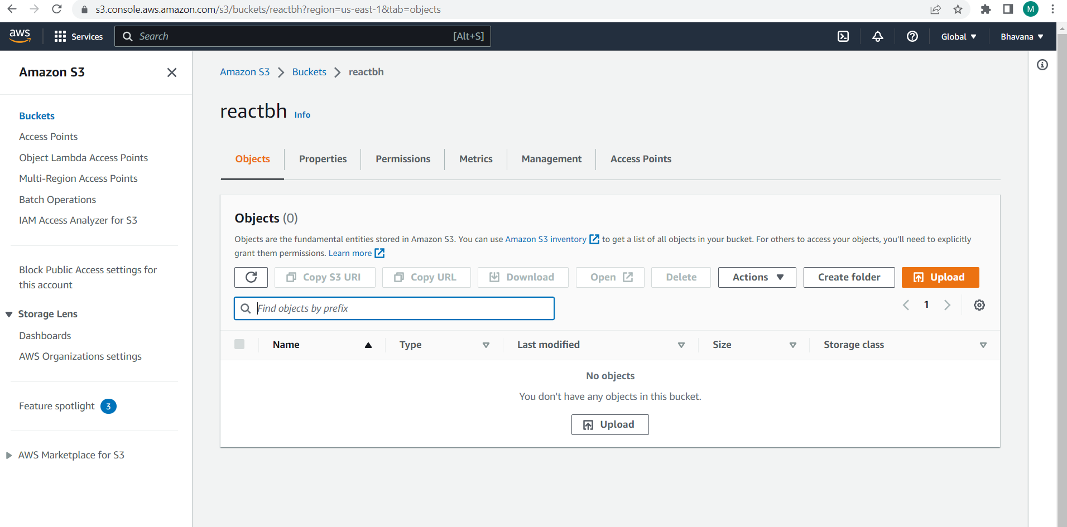

Step2:

Download nodejs in windows

Open vs code and enter command->npm I

->npm run build

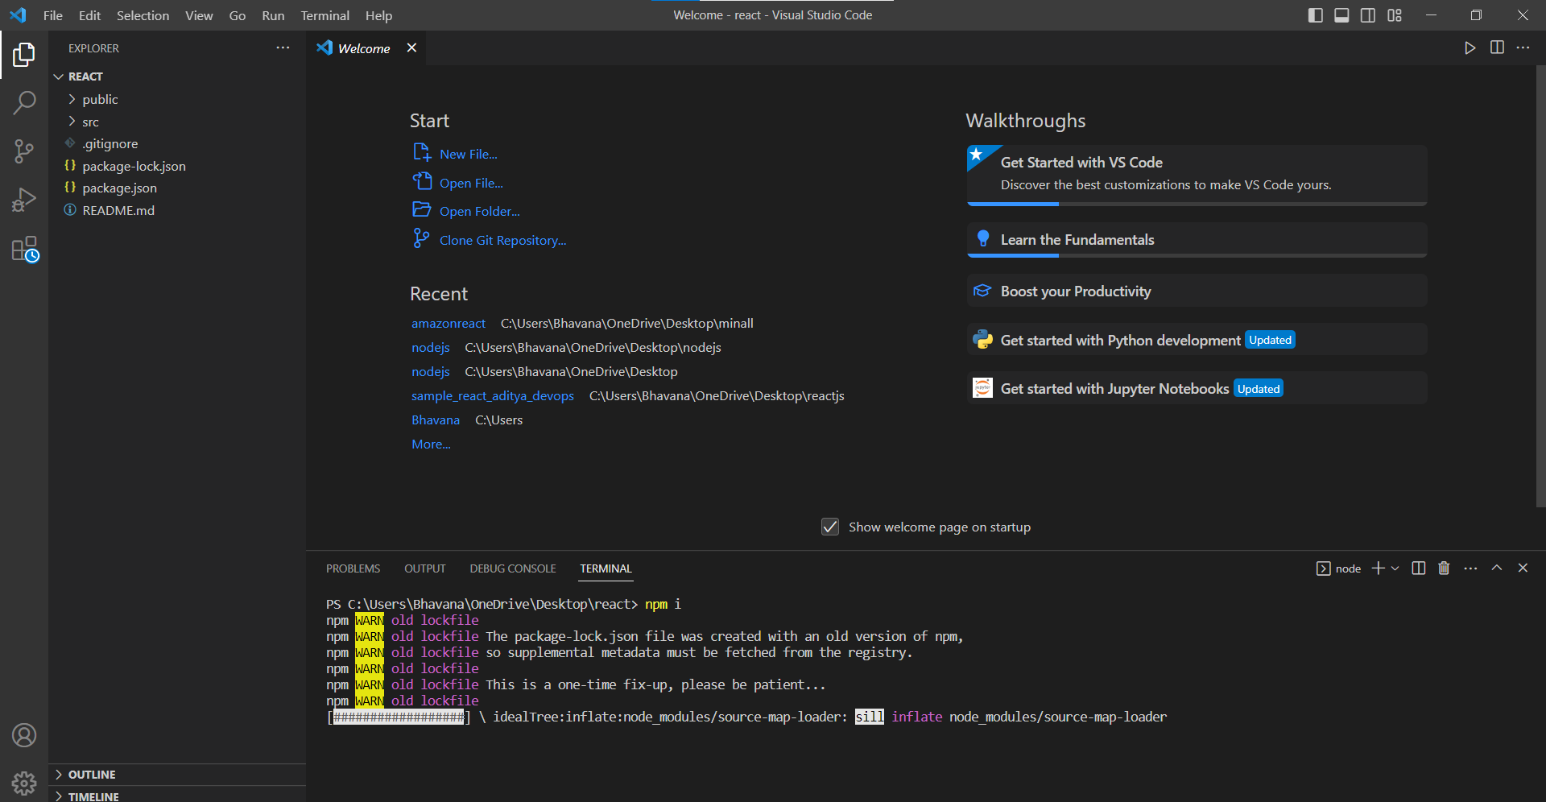

Step3:

Upload the build folder into the created bucket

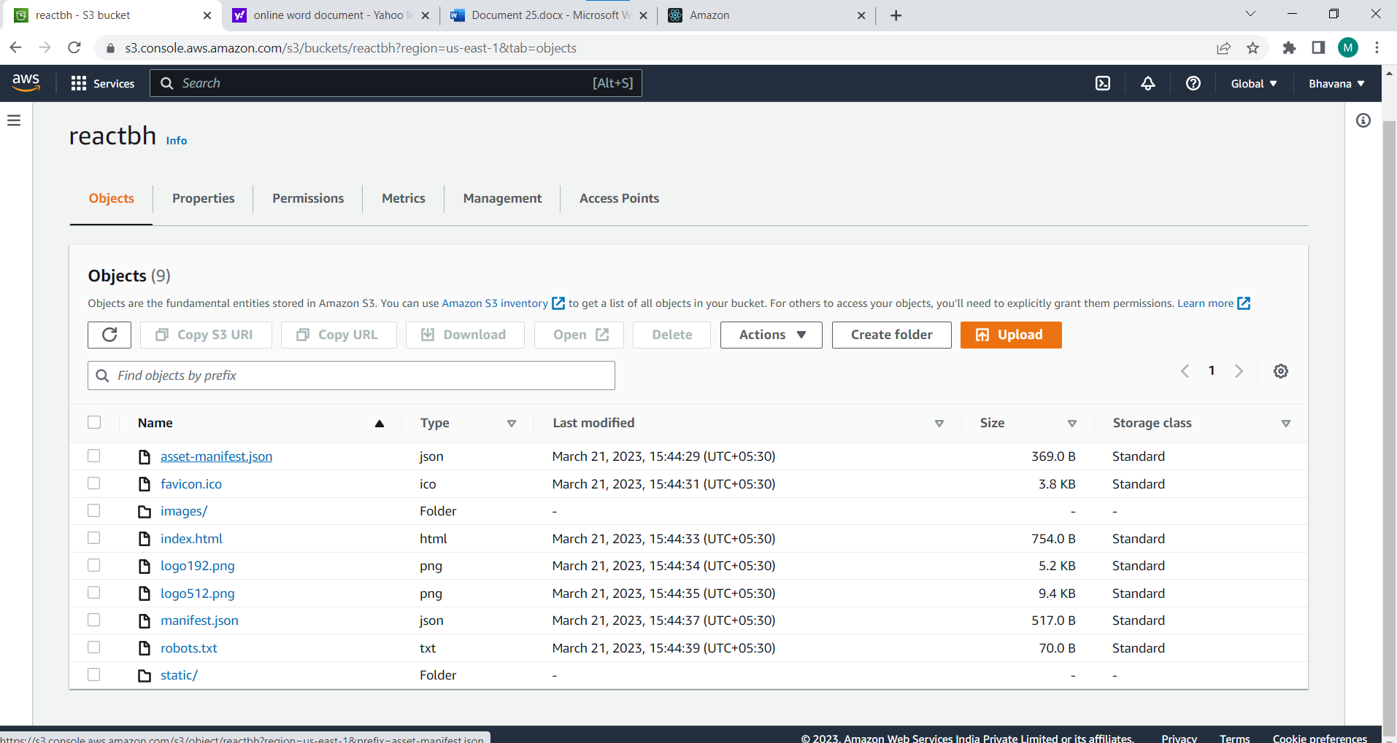

Step 4:

Click static website hosting and enable it

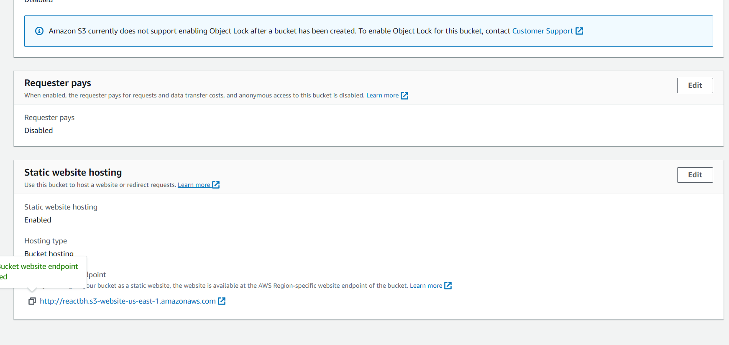

Step 5:copy the url paste it on new tab

